Project Title
Matrix Chain Multiplication Optimizer using Interval Dynamic Programming
Project Report submitted for the partial fulfilment of grade for the course

Data Structures and Algorithms -3 (25CS2103E)
in

A.Y. 2026-2027

Submitted by
Ayusha Das (2520039624)
Tokala Pratyusha Reddy (2520030612)
M. Manasa (2520030438)

Team Number: 20
Section: 1

Under the guidance of

Dr. Ch Anuradha

Assistant Professor, Department of Computer Science Engineering
Hyderabad-500090, Telangana, India.

K L (Deemed to be) University
DEPARTMENT OF COMPUTER SCIENCE ENGINEERING



DECLARATION

The Mini Project Report entitled “Matrix Chain Multiplication Optimizer using Interval Dynamic Programming” is a record of Bonafide work of Ayusha Das – 2520039624, Tokala Pratyusha Reddy – 2520030612, M. Manasa – 2520030438 submitted in partial fulfillment for the award of B. Tech in Computer Science and Engineering to the K L University. The results embodied in this report have not been copied from any other departments/University/Institute.

Ayusha Das – 2520039624
Tokala Pratyusha Reddy – 2520030612
M. Manasa – 2520030438

K L (Deemed to be) University
DEPARTMENT OF COMPUTER SCIENCE ENGINEERING
CERTIFICATE

This is to certify that the mini project based report entitled “Matrix Chain Multiplication Optimizer using Interval Dynamic Programming” is a bonafide work done and submitted by Ayusha Das – 2520039624, Tokala Pratyusha Reddy – 2520030612, M. Manasa – 2520030438 in partial fulfillment of the requirements for the award of the degree of BACHELOR OF TECHNOLOGY in Department of Computer Science Engineering, K L (Deemed to be University), during the academic year 2026-2027.

Signature of the Supervisor

Signature of the HOD Signature of the External Examiner

ACKNOWLEDGEMENT

The success in this project would not have been possible but for the timely help and guidance rendered by many people. Our wish to express my sincere thanks to all those who has assisted us in one way or the other for the completion of my project.

Our greatest appreciation to my guide, Dr. Ch Anuradha, Assistant Professor, Department of Computer Science Engineering which cannot be expressed in words for her tremendous support, encouragement and guidance for this project.

We express our gratitude to Dr. P.Venkateshwar Rao (CSE), Head of the Department of Computer Science Engineering for providing us with adequate facilities, ways and means by which we are able to complete this project-based Lab.

We thank all the members of teaching and non-teaching staff members, and also who have assisted me directly or indirectly for successful completion of this project. Finally, I sincerely thank my parents, friends and classmates for their kind help and cooperation during my work.

Ayusha Das – 2520039624
Tokala Pratyusha Reddy – 2520030612
M. Manasa – 2520030438

TABLE OF CONTENTS
S.No. | Contents | Page no.
1. | Abstract | 6
2. | Introduction | 7
3. | Literature survey | 8
4. | Problem Statement and Objectives | 10
5. | Hardware and Software requirements | 11
6. | Implementation | 12
7. | Results & Discussion | 15
8. | Conclusion & Future Scope | 17
9. | References | 18
1.ABSTRACT
Multiplying a chain of matrices can be bracketed in many ways. Every bracketing gives the same product, yet the number of scalar multiplications they need can differ by orders of magnitude. This project presents the Matrix Chain Multiplication Optimizer, a command-line tool that uses interval dynamic programming to find the cheapest multiplication order for a chain of up to 500 matrices. Given only the matrix dimensions, the tool builds a cost table and a split table in O(n³) time and O(n²) space, then reports the minimum number of scalar multiplications and the optimal parenthesization. It also evaluates the naive left-to-right strategy and compares the two, showing the savings and the speed-up. The tool was verified on the classic six-matrix example, where the cost falls from 40,500 to 15,125 multiplications, and on a randomly generated chain of 500 matrices, where it falls from 60,694,424 to 6,597,760, about 89 percent fewer. The project demonstrates optimal substructure, overlapping subproblems and bottom-up table filling, and shows why the order of evaluation matters in scientific computing, graphics and machine learning workloads.
Team Name:
Team Logo (if any):
Team Members:
- Ayusha Das, 2520039624
- Tokala Pratyusha Reddy, 2520030612
- M. Manasa, 2520030438

- INTRODUCTION
Matrix multiplication is associative, so a product A1 × A2 × … × An has the same value however it is bracketed. The cost is not the same. Multiplying a p × q matrix by a q × r matrix needs p·q·r scalar multiplications, so the order in which the products are formed decides how much work is done. For example, with A of size 10×100, B of size 100×5 and C of size 5×50, the bracketing (AB)C needs 7,500 multiplications while A(BC) needs 75,000, ten times as many.
Trying every bracketing is not practical, because their number grows as the Catalan numbers, which is exponential in n. The matrix chain problem has optimal substructure and overlapping subproblems, which makes it a classic application of dynamic programming. This project turns that idea into a working tool. It reads the matrix dimensions, finds the minimum cost and the optimal parenthesization, and compares them with naive left-to-right multiplication for chains of up to 500 matrices.
The rest of this report is organised as follows. Section 3 surveys related work, Section 4 states the problem and objectives, Section 5 lists the requirements, Section 6 gives the implementation, Section 7 presents the results and discussion, Section 8 concludes with future scope, and Section 9 lists the references.
- LITERATURE SURVEY
The following existing work on the matrix chain multiplication problem was studied. The URLs are listed in Section 9 (References) under the same numbers.
[1] Dynamic Programming (i): Multiplying Matrices (blog post, alexmolas.com). The post shows that the multiplication order changes the number of arithmetic operations even though the product stays the same, and explains why searching all groupings is impractical. It implements both a brute-force solution and a memoized dynamic programming solution in Python, and reports that memoization is faster by up to about 100,000 times for chains of around 18 matrices. It is a practical demonstration of why overlapping subproblems matter.
[2] How to Solve Matrix Chain Multiplication using Dynamic Programming? (HelloACM). The page works through an example in which different parenthesizations of three matrices need very different numbers of multiplications. It presents three solutions in pseudocode: plain recursion that splits the chain at every position, a memoized version with a lookup table, and a bottom-up iterative version that builds from short chains to long ones, whose running time is stated as O(n³).
[3] Dynamic Programming: Matrix chain multiplication, CLRS 15.2 (lecture notes, Bowdoin College CS231, Spring 2014). The lecture defines the minimum cost m(i, j) recursively and notes that naive recursion takes exponential time because it recomputes subproblems. Storing results in an n × n table, by memoization or by filling the table by chain length, reduces the work to O(n³). The notes compute only the optimal cost and leave recovering the actual multiplication order as an exercise.
[4] Call Structure for the Chained Matrix Multiplication Problem (OpenDSA visualization, SPLICE catalog). This slideshow visualization was created by researchers at Virginia Tech and Universidad Rey Juan Carlos. It shows the tree of recursive calls made by a dynamic programming solution to the chained matrix multiplication problem, which helps learners see where subproblems repeat. It is an educational illustration and not an optimization tool.
[5] Matrix Chain Multiplication (AfterAcademy problem page). The page frames the task as choosing the multiplication order, not performing the multiplications. The input is an array of dimensions and the output is the minimum number of multiplications, illustrated with two worked examples costing 30,000 and 6,000 multiplications. It gives no solution code or complexity analysis and only links to an online editor for practice.
[6] Matrix Chain Multiplication using Dynamic Programming (Medium article). The article explains that the number of groupings grows exponentially and that dynamic programming avoids trying them all. It walks through a four-matrix example, filling one table for the minimum number of multiplications and another for the bracket positions. It uses mathematical notation and tables, and it does not name a programming language or state a formal complexity.
Observation: the surveyed material mostly explains the method, computes only the minimum cost, or illustrates the recursion. This project goes further by also printing the optimal parenthesization, comparing it with naive left-to-right multiplication, validating the input and supporting chains of up to 500 matrices.
- Problem Statement and Objectives
Problem Statement:
To develop an optimization tool that uses dynamic programming to find the order of multiplying a chain of up to 500 matrices that minimizes the total number of scalar multiplications.
Problem Description:
Given only the matrix dimensions, the application must output the minimum cost and the optimal parenthesization, and compare the optimized strategy with naive left-to-right multiplication.
Objectives:
1. To model the problem with an interval dynamic programming recurrence that has optimal substructure and overlapping subproblems.
2. To compute the minimum number of scalar multiplications for chains of up to 500 matrices in O(n³) time and O(n²) space.
3. To display the optimal parenthesization and its execution cost.
4. To compare the optimized order with naive left-to-right multiplication and report the savings and speed-up.
5. To validate the input and verify the tool on known examples.
- HARDWARE AND SOFTWARE REQUIREMENTS
Hardware Requirements:
- Computer with a dual-core processor or better
- 4 GB RAM or more (the tables for 500 matrices need well under 100 MB)
- Keyboard, display and a few megabytes of free disk space
Software Requirements:
- Operating system: Windows, Linux or macOS
- Python 3.8 or later (standard library only, no extra packages)
- Text editor or IDE such as VS Code, PyCharm or IDLE
- Terminal or command prompt to run the program
- IMPLEMENTATION

The program is a single Python file, matrix_chain.py, divided into four modules. The input is the number of matrices n followed by the n + 1 dimensions d0 … dn, so that matrix Ai has d(i−1) rows and di columns. It is run with python3 matrix_chain.py < input.txt.
Module 1: Input reading and validation (read_input)
import sys
import time
MAX_MATRICES = 500
def read_input():
"""Module 1: read n and the n + 1 dimensions from standard input and validate them."""
data = sys.stdin.read().split()
if not data:
raise ValueError("No input given.")
n = int(data[0])
dims = list(map(int, data[1:2 + n]))
if n < 1:
raise ValueError("Need at least one matrix.")
if n > MAX_MATRICES:
raise ValueError(f"At most {MAX_MATRICES} matrices are allowed.")
if len(dims) != n + 1:
raise ValueError(f"Expected {n + 1} dimensions, got {len(dims)}.")
if any(d <= 0 for d in dims):
raise ValueError("All dimensions must be positive integers.")
return n, dims
Module 2: DP table construction (optimize)
def optimize(dims):
"""Module 2: fill the DP tables. m[i][j] = minimum cost of Ai..Aj, s[i][j] = best split k."""
n = len(dims) - 1
m = [[0] * (n + 1) for _ in range(n + 1)]
s = [[0] * (n + 1) for _ in range(n + 1)]
for length in range(2, n + 1): # chain length
for i in range(1, n - length + 2): # start of the chain
j = i + length - 1 # end of the chain
best = float("inf")
for k in range(i, j): # try every split point
cost = m[i][k] + m[k + 1][j] + dims[i - 1] * dims[k] * dims[j]
if cost < best:
best = cost
s[i][j] = k
m[i][j] = best
return m, s
Module 3: Parenthesization reconstruction (parenthesize)
def parenthesize(s, i, j):
"""Module 3: rebuild the optimal bracketing of Ai..Aj from the split table s."""
if i == j:
return f"A{i}"
k = s[i][j]
return "(" + parenthesize(s, i, k) + " x " + parenthesize(s, k + 1, j) + ")"
Module 4: Naive comparison and driver (naive_cost, naive_order, main)
def naive_cost(dims):
"""Module 4a: cost of ((A1 x A2) x A3) x ... x An, multiplying strictly left to right."""
return sum(dims[0] * dims[k] * dims[k + 1] for k in range(1, len(dims) - 1))
def naive_order(n):
"""Module 4b: the bracketing used by the naive strategy."""
order = "A1"
for i in range(2, n + 1):
order = f"({order} x A{i})"
return order
def main():
n, dims = read_input()
start = time.time()
m, s = optimize(dims)
elapsed = time.time() - start
best, naive = m[1][n], naive_cost(dims)
print(f"Matrices : {n}")
print(f"Optimal cost : {best}")
if n <= 20: # long chains are too wide to print
print(f"Optimal order : {parenthesize(s, 1, n)}")
print(f"Naive order : {naive_order(n)}")
print(f"Naive cost : {naive}")
saved = naive - best
percent = saved / naive * 100 if naive else 0.0 # a single matrix needs no multiplication
speedup = naive / best if best else 1.0
print(f"Savings : {saved} ({percent:.2f}% fewer multiplications)")
print(f"Speed-up : {speedup:.2f}x")
print(f"DP time : {elapsed:.3f} s")
if __name__ == "__main__":
try:
main()
except ValueError as err:
print(f"Error: {err}")
sys.exit(1)

- RESULTS & DISCUSSION
The program was run on four inputs. The screenshots below show the actual terminal output of each run.
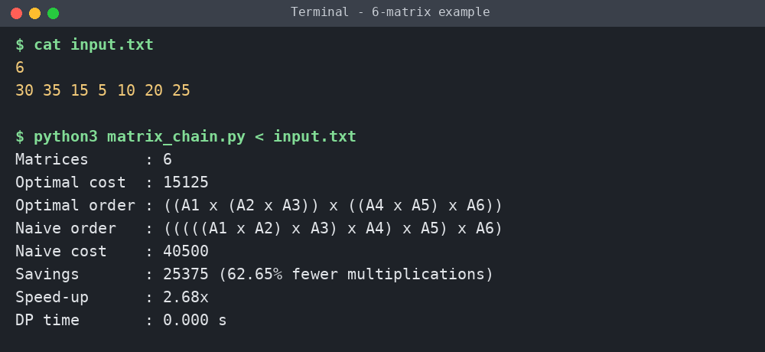
Fig. 7.1: Six-matrix example. The optimal order costs 15,125 multiplications against 40,500 for the naive order, saving 62.65 percent.
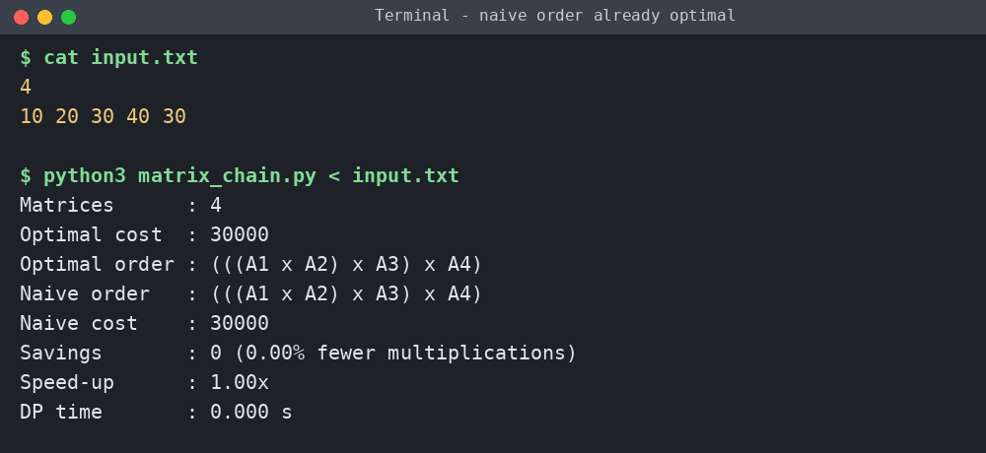
Fig. 7.2: Four matrices where the naive left-to-right order is already optimal, so both strategies cost 30,000 and the tool reports zero savings.
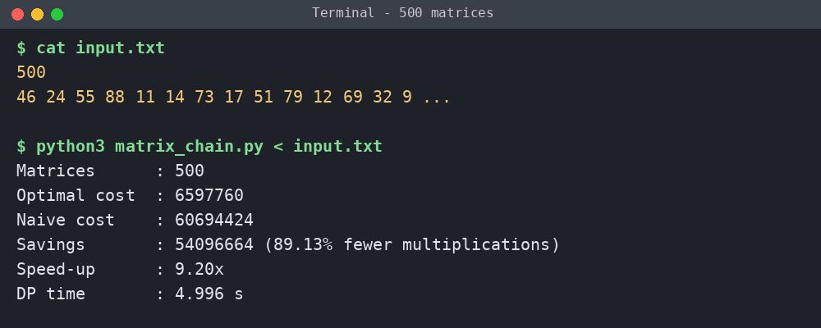
Fig. 7.3: Random chain of 500 matrices with dimensions from 5 to 100. The optimal cost is 6,597,760 against 60,694,424 for naive, saving 89.13 percent in about 5 seconds.
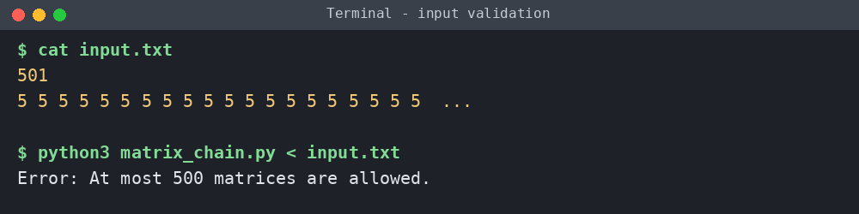
Fig. 7.4: Input validation. A chain of 501 matrices is rejected with an error message because the constraint is at most 500 matrices.
Summary of the runs:
Test | Matrices | Optimal cost | Naive cost | Savings | DP time
Classic example | 6 | 15,125 | 40,500 | 62.65% | < 0.001 s
Naive already optimal | 4 | 30,000 | 30,000 | 0.00% | < 0.001 s
Random chain | 500 | 6,597,760 | 60,694,424 | 89.13% | about 5 s

Discussion: the result for the six-matrix example, 15,125 multiplications, matches the well-known textbook answer, which confirms the recurrence and the split table. The saving depends on the dimensions: it is large when dimensions vary a lot and zero when the naive order happens to be best. The running time grows as O(n³), and 500 matrices take about 5 seconds in plain Python, so the limit of 500 matrices is practical. Timings depend on the machine used.
- CONCLUSION & FUTURE SCOPE
The Matrix Chain Multiplication Optimizer met its objectives. It models the problem with an interval dynamic programming recurrence, finds the minimum cost and the optimal parenthesization for chains of up to 500 matrices, and compares the result with naive left-to-right multiplication. Tests confirmed the textbook answer of 15,125 multiplications for the six-matrix example and a saving of about 89 percent on a random 500-matrix chain, with running time growing as O(n³).
Future scope:
Near term: add a graphical or web front end that shows the cost and split tables step by step, and export results to a file.
Medium term: rewrite the core loop in C++ or with NumPy for speed, and use the optimal order to multiply real matrices and measure the actual time saved.
Long term: study the Hu–Shing algorithm, which solves the problem in O(n log n) time, and extend the cost model to sparse matrices or parallel hardware.
- REFERENCES
1. Dynamic Programming (i): Multiplying Matrices, alexmolas.com. https://alexmolas.com/2020/12/31/dynamic-programming-i.html (accessed 11 October 2026).
2.How to Solve Matrix Chain Multiplication using Dynamic Programming?, HelloACM. https://helloacm.com/how-to-solve-matrix-chain-multiplication-using-dynamic-programming/ (accessed 11 October 2026).
3.Dynamic Programming: Matrix chain multiplication (CLRS 15.2), lecture notes, Bowdoin College CS231, Spring 2014. https://tildesites.bowdoin.edu/~ltoma/teaching/cs231/spring14/Lectures/12-dynamicAndGreedy/matrixchain.pdf (accessed 11 October 2026).
4.Call Structure for the Chained Matrix Multiplication Problem, OpenDSA visualization, SPLICE catalog, Virginia Tech. https://splice.cs.vt.edu/catalog/item/13513 (accessed 11 October 2026).
5.Matrix Chain Multiplication, AfterAcademy. https://afteracademy.com/problem/matrix-chain-multiplication (accessed 11 October 2026).
6.Matrix Chain Multiplication using Dynamic Programming, Medium. https://medium.com/@souravganguly_32007/matrix-chain-multiplication-using-dynamic-programming-cdd711f0ca49 (accessed 11 October 2026).
7.T. H. Cormen, C. E. Leiserson, R. L. Rivest and C. Stein, Introduction to Algorithms, 3rd ed., MIT Press, 2009, Section 15.2: Matrix-chain multiplication.

